BIOLOGY
PAPER II
CONFIDENTIAL INSTRUCTIONS
QUESTION 1 AND 2
- No Confidential instructions

QUESTION 3
- Provide each candidate with the following
- One Irish potato tuber labelled X
- Razorblade/knife
- Three small beakers/petri dishes
- Salt solution of 20% and 50 in any suitable containers
- Distilled water in any suitable container

QUESTION 4
- Each candidate should be provided with the following
- One soaked beans labelled P
- One sisal piece (7 – 10 cm length) labelled Q
MOCK PREPARATIONS
CHEMICALS APPARATUS AND MATERIALS | QUANTITY
- Irish potato tuber | Enough for all candidates
- Salt
- Distilled water
- Sisal
- Soaked bean

MARKING SCHEME
FOR
BIOLOGY
PAPER II
- Place equal amounts of starch solution in three test tubes labelled A, B and C
- To each test tubes add equal amount of ptyalin enzyme
- Put test tube A into a beaker containing cold water 9with ice cubes)
- Test tube B should be in a water both maintained at 37⁰C (thermometer use)
- Boil the contents of each test tube with iodine solution for a starch test
- In test tube A the solution will change to blue – black indicating presence of starch.
- In test tube B, no colour change will be observed due to iodine solution showing absence of starch
- In test tube C, solution changes to blue – black showing presence of starch
- In test tube B, the starch might be changed to another substance by the ptyalin
- Enzymes work best at a particular temperature.
- – Collect green leaves
- Grid the leaves in mortar using pestle
- Squeeze the grinded leaves to obtain an extract
- Cut a strip of filter paper
- Put a drop of extract on the filter paper strip (4 cm from bottom)
- Clip the bottom edge of filter with the extract in alcohol in a beaker about 2 cm from the extract spot
- Alcohol rises up the strip of filter paper dissolving the extract
- The alcohol will separate the extract into different Coloured spot which will be observed on the filter paper
- The colour appearing may include: green yellow, red orange and the green indicates the chlorophyll as a pigment while the yellow and orange are for other pigments
- Green leaves contain different types of pigments.
(10 Marks)

- vi).
 | Potato strip distilled water | Potato strip in 20% salt solution | Potato strip in 50% salt solution
Flexibility | Less flexible (Firm) | More flexible | Most flexible
Length | More than 3cm ie 3.3cm | Less than 3 cm ie 2.8cm | Less than the one in the 20% ie 2.5 cm
(6 marks)
vii). In tube C, the salt solution is stronger than the cell sap of the potato cells, so these cells will lose water more by osmosis.
(2 marks)
vii). Water uptake in plants
- Providing support to plant tissues
- Enhance opening and closing of stomata
(6 marks)

(10 Marks)
- a). i. Varies _________ mm
ii). Length of
Drawing = Magnification x length of drawing
= x3.5 x _________ mm
(3 marks)
b).
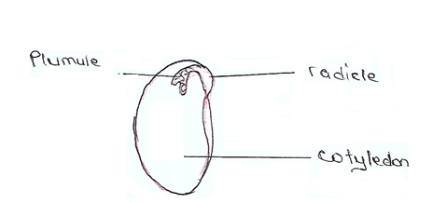
c). Starch
d). Are succulent/store water and draw on this store for photosynthesis
- Are reduced to spines/ to reduce water loss.
(10 marks)

